Rice Pudding with Vermicelli

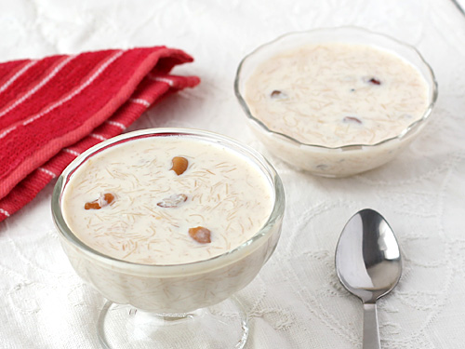

Ingredients

1 cup roasted vermicelli
1.5-2.5 cups of 2% milk (the amount will depend on how thick you like the dish)
1 can evaporated milk
3-4 tbs. sugar (depends how sweet you like it and if you use fruit or not)
1/3 cup chopped nuts – your preference
1 tbs. dried coconut powder
½ tsp. cardamom

Toppings (optional)
Chopped nuts
Raisins
Dried fruit of your choice

Instructions
- Use a large pot, heat to low-medium
- Warm the 2% milk in the microwave for approx. 2 minutes
- Add milk to the heated pot. Stir.
- Add the vermicelli and stir consistently for 5 minutes
- Microwave the evaporated milk for 2 minutes
- Add nuts, sugar, coconut powder, and cardamom to the pot mixture and stir
- Add in the evaporated milk and combine everything
- Let it rest to thicken, portion into bowls or cups and add toppings of choice!

To make it sweeter:
- Add 1 tbs. sugar
- Add ground cinnamon or cinnamon stick (may want to leave out the cardamom with this ingredient)
- Add fruit such as berries or mangoes

