Textured Vegetarian Protein (vegan) Pasta
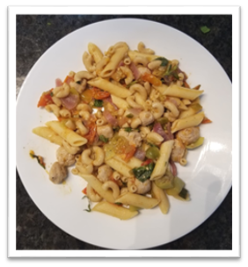
Ingredients

5 cups cooked macaroni (1 ¾ cup uncooked)
4 cups cooked penne (2 cups uncooked)
2.5 cup cooked TVP -textured vegetable protein (200 g or 1 cup uncooked)
4 cups chopped red onion
2-3 chopped garlic cloves
1 cup chopped green onion
1.5 cup chopped pepper of choice (hot or mild, or sweet bell pepper)
10 cups chopped tomatoes
1 cup fresh basil
3 tbs oil of choice
1 tsp pepper
1 tsp salt (use less if you want to use cheese as a garnish)

Instructions
- Heat a large pan/wok/pot on medium-high
- Add oil, red onion, and garlic. Cook and stir to desired texture
- Add peppers and green onions. Stir and reduce heat to medium
- Add tomatoes. Stir and increase heat to medium-high
- Add basil and stir. Cook down the sauce to desired consistency
- Add salt and pepper. Stir.
- Soak TVP in warm water for half hour and cook until soft
- Add TVP and pasta. Stir to combine all ingredients

Yields: 5 cups
Sauce = 10 vegetable servings

