Edamame Stir-fry

​Ingredients
1 package frozen edamame (500g)
2 ¼ cup chopped onions
2 cups chopped tomatoes
3 cups broccoli
1-2 chopped peppers of choice (bell pepper, hot peppers etc.)
1 tbs. oil of choice
1 cup water

Spices (you can use whichever spices you enjoy)
1 tsp. cumin seeds
¼ tsp. chili peppers (optional for spiciness)
½ tsp. turmeric
½ tsp. salt
½ tbs. coriander powder

Instructions
- Boil thawed edamame for about 15 minutes until cooked
- Add oil and cumin seeds to a heated pan. Stir and let brown
- Add onions and stir. Cook to desired texture – for demo, cooked until slightly transparent
- Add peppers, stir, and cook for 2 minutes
- Add tomatoes, stir, and cook for 2 minutes
- Add spices and water, stir, and bring to a rolling boil
- Add edamame, stir, and cover. Cook for 2 minutes
- Add broccoli, stir, and cook until desired texture is reached
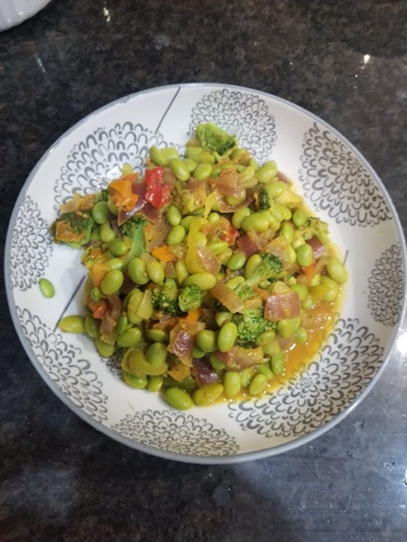
Side options:
- rice (parboiled or brown rice)
- Whole grain pasta
- Crackers
- Roti
- Whole grain bread

