Corn Salad
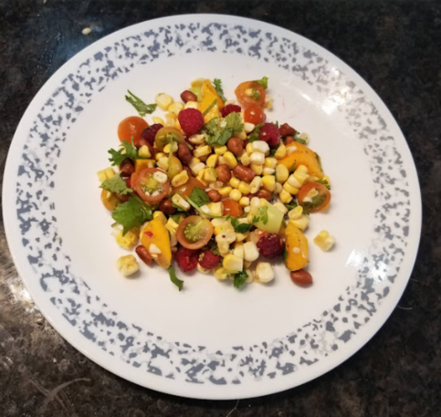

Ingredients

½ cup raw peanuts
½ tbs. oil of choice
¼ tsp. salt
½ tsp. black peppers
½ tsp. coriander seeds
1 cob of corn (1.5 cups of kernels)
¾ cup chopped tomatoes
1 pepper chopped – hot or sweet, your preference
½ cup raspberries
¾ cup chopped mango
1 handful of coriander (or parsley)

Instructions

- Roast the peanuts in a pan with oil on medium heat. Once they start to brown, add seasonings, and remove from heat.
- Cut off the corn kernels from the cob. You can either use raw corn or cook them for this recipe, whichever you prefer.
- Add everything to a mixing bowl and stir.
- Garnish with the coriander/parsley.
- Serve and enjoy!

Yields 4 cups

1 serving = 1 cup = ¼ protein serving, 1 serving of fruit and vegetables

To make it a meal:

Carbohydrate options:
- Side dish of potatoes
- Side of rice
- Side of quinoa
- Roti, tortilla, or pita
Protein options:
- Chicken
- Fish
- Tofu

