Chicken Quinoa Salad
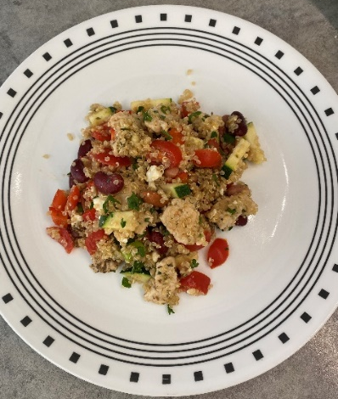
Ingredients

- 1 cup cherry tomatoes – quartered
- 1 cup chopped zucchini – raw or cooked (your preference)
- 2/3 cup red bell pepper – chopped
- 1 cup beans – your preference of medley, canned and rinsed or dried and soaked
- 1 tbs. oil of choice
- 1.5 tbs. red wine vinegar
- 1 tsp oregano – dried or fresh and minced
- ¼ tsp pepper
- ¼ cup feta cheese - crumbled
- ½ chicken breast – ¼ pound or 140 grams
- 2/3 cup raw quinoa (2 cups cooked)
- 1 1/3 cup water
- 2 tbs. parsley
- 2 tbs. green onion

Instructions
- Pour quinoa into a pot with water. Tap any floating quinoa with a spoon so it is fully emerged. Cook for 10-12 minutes, stirring every 3-4 minutes
- Slice chicken across the fibers (it will be more tender this way), then cut them into ½ inch – 1-inch cubes
- Heat a pan to medium and add enough oil to coat the pan
- Add chicken to the pan, leaving enough space between the chicken pieces to fully cook through
- Add oregano to the chicken and stir
- Once browning begins, add red wine vinegar and the rest of the oil. Stir.
- Cut the green onions lengthwise once, then chop finely to release the flavor
- Check the chicken with a meat thermometer. Once it reaches 165 degrees Fahrenheit or more, it is safe to eat
- Bunch the parsley together and cute as finely as you like
- Grab a large container or bowl and add all the veggies, beans, chicken with juice, and 2 cups of cooked quinoa. Mix it all together.
- Top it off with green onions, parsley, broken up feta cheese (easiest to do with your hands), and pepper
- Enjoy! Yields 4 meals

